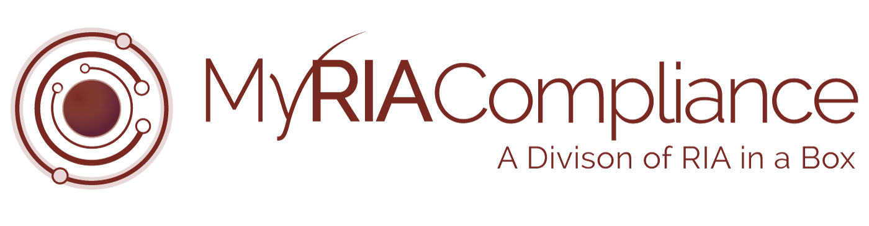*The following document is provided to You as a sample only.  Prior to using or implementing this document or any portion thereof, You should tailor the contents, including any highlighted sections, to fit your specific situation and should consult relevant regulatory authorities and/or legal counsel. RIA in a Box and its compliance division (“We”) do not represent or warrant that the contents of the document are suitable for You from a compliance, regulatory, legal, or any other perspective. We shall have no responsibility or liability for your use or non-use of the document or any portion thereof. We are not law firms, investment advisory firms, or CPA firms and do not provide legal advice or opinions.*

Copyright © 2018 RIA in a Box LLC

**Template Financial Plan Disclosure**

This financial plan is intended to provide general information and guidelines designed to assess current financial situations and assist in decision-making. This material may also contain general educational topics about investing and financial matters. The plan was created based on information and assumptions provided by you. Certain elements of the plan may change over time as your information and assumptions also change. Likewise, current tax rules and regulations may also change that could have an impact on your plan. Because of this, you are encouraged to regularly review and update your plan as necessary.

This plan is not meant to provide any tax, accounting or legal advice. You should always consult with a qualified professional in those specific areas before implementing any portion of the plan.

Past performance is not indicative of future performance. Market conditions may change over time as well as your investments and investment objectives. There is no guarantee that any goals will be achieved or plans of action will be successful. In some instances, rates or return may be used to demonstrate a concept or for educational purposes. These rates are not a guarantee of any future performance.